AP Test Questions for Limits



(A) 0 (B)  (C) 1 (D) 4 (E) nonexistent

2. 

(A) -5 (B) -2 (C) 1 (D) 3 (E) nonexistent

3.  is

(A) 0 (B)  (C)  (D) 1 (E) nonexistent

4. If 

(A) 0 (B) 1 (C) 2 (D) 4 (E) nonexistent

5. The graph of the function is shown in the given figure. Which of the following statement about  is true?

a

b

1

2

3

4

(A) 

(B) 

(C) 

(D)  (E) 

6. If the graph of  has a horizontal asymptote  and a vertical asymptote x = -3,

then 

(A) -5 (B) -1 (C) 0 (D) 1 (E) 5

7. If the function  is continuous for all real numbers and if  when ,

then 

(A) -4 (B) -2 (C) -1 (D) 0 (E) 2

8. Let  be the function defined by the following

(A) 0 only

(B) 1 only

(C) 2 only

(D) 0 and 2 only

(E) 0, 1, and 2



For what values of x is NOT continuous?

9. If , then is

(A)  (B)  (C)  (D) 0 (E) nonexistent

10. Let  be the function given by . For what positive values of  is continuous for all real numbers ?

(A) None (B) 1 only (C) 2 only (D) 4 only (E) 1 and 4 only

11. **Find the value of k, if it exists, that will make each function continuous at x =1.**



12. **Find g(x),that will make the function continuous at x =1.**



a. x

b. 

c. 6-x

d. 

e. 



13. The graph of a function is shown above.

At which value(s) of x iscontinuous?

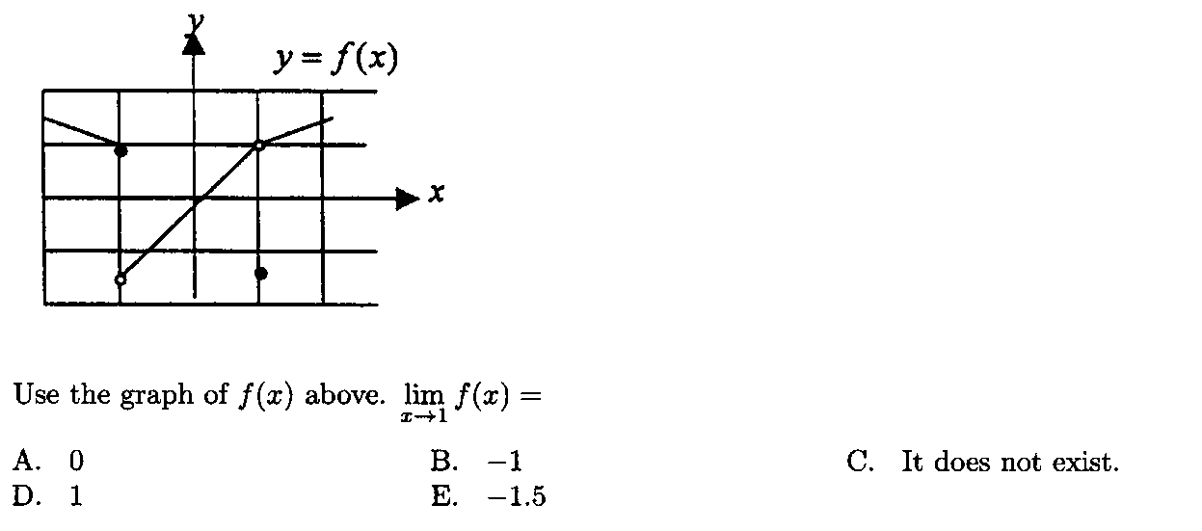

14.

15. For , the horizontal line  is an asymptote for the graph of the function . Which of the following statements must be true? 2003 AB3 E  
  
(A)  (B  for all   
  
(C)  is undefined. (D)  (E) 

|  |  |  |  |
| --- | --- | --- | --- |
| *x* | 0 | 1 | 2 |
| *f*(*x*) | 1 | *k* | 2 |

16. The function *f* is continuous on the closed interval [0, 2] and has values that are given in the table above. The equation  must have at least two solutions in the interval [0, 2] if *k* = 1998 AB 26 A  
  
(A) 0 (B)  (C) 1   
  
(D) 2 (E) 3